

**Arab American University**

**Faculty of Engineering and Information Technology**

**Assembly lab**

**Shift, Rotate, Multiplication and Division Instructions**

**Prepared by:Suha Waleed Alardah**

**ID:201811033**

**To:Dr.Tareq Zanoon**

**To:Mrs.NOOR**

Introduction :

We complete the lap6 about Shift, Rotate, Multiplication and Division Instructions , and knowing the difference between logical and arithmetic shifts, and learn how we can use MUL and DIV instruction according to the many tasks. So we will do some tasks to Concept reinforcement.

Objective:

Learn the instructions such as MUL , DIV, ROR , ROL , SHR , SHL

Tasks:

Task#1: Enter 5(3digit) number?

Task#2: Validate that all number are less than 255?

Task#3: Add 5number then print the result on the screen?

dosseg

.model small

.stack 100

.data

msg db " PLZ enter a 5 number less than 255 and show the result ",10,13,"$"

.code

main:

mov ax,@data

mov ds,ax

mov ah,9

mov dx, offset msg

int 21h

mov ch,5

out:

mov bh,3

mov bl,100

mov dx,0

mov cl,10

lp1:

mov ah,1

int 21h

sub al,30h

mov ah,0

mul bl

add dx,ax

dec bh

jz lpend

mov ah,0

mov al,bl

div cl

mov bl,al

jmp lp1

lpend:

cmp dx,255

ja error

push dx

mov ah,2

mov dl,10

int 21h

dec ch

jnz out

mov ax,0

mov cl,5h

pp2:

pop dx

add ax,dx

dec cl

jnz pp2

;

mov cl,10

mov dx,0

mov bx,1000

mov ch,4h

;

lprint:

div bx

push dx

add dx,30h

mov ah,2

int 21h

mov ax,bx

div cl

mov bx,ax

mov dx,0

pop ax

dec ch

jnz lprint

error:

mov ah,4ch

int 21h

end main

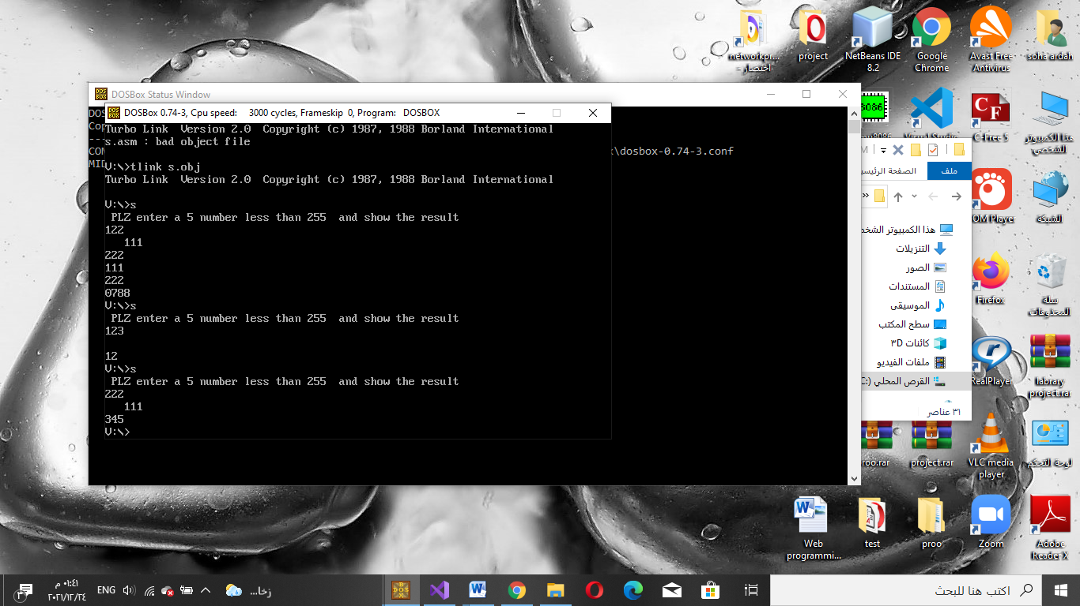

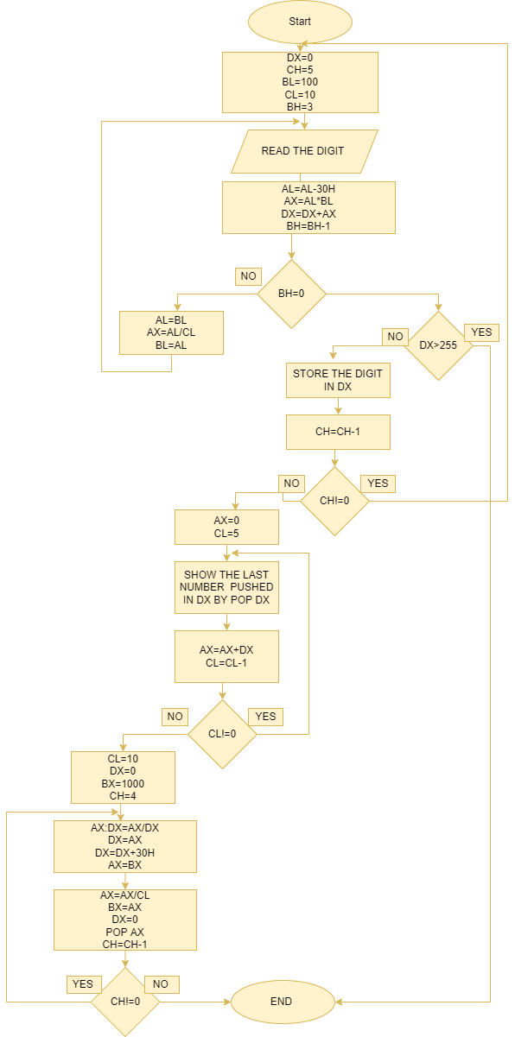

*Results:*

The solution above contains different instructions Shift, Rotate, Multiplication and Division Instruction

*Conclusions:*

We learn in this experiment Shift, Rotate, Multiplication and Division Instructions facilitates the use of the user, and makes the assembly language more enjoyable and easier for the programmer to deal with